

# Course Project Recap

Regardless of which track you have chosen to complete, your goals for this project are:

* Complete the PACE Strategy Document to plan your project while considering your audience members, teammates, key milestones, and overall project goal.
* Create a project proposal for the data team.

# Relevant Interview Questions

Completing this end-of-course project will empower you to respond to the following interview topics:

* As a new member of a data analytics team, what steps could you take to get 'up to speed' with a current project? What steps would you take? Who would you like to meet with?
* How would you plan an analytics project?
* What steps would you take to translate a business question to an analytical solution?
* Why is actively managing data an important part of a data analytics team's responsibilities?
* What are some considerations you might need to be mindful of when reporting results?

**Reference Guide**

This project has three tasks; the following visual identifies how the stages of PACE are incorporated across those tasks.

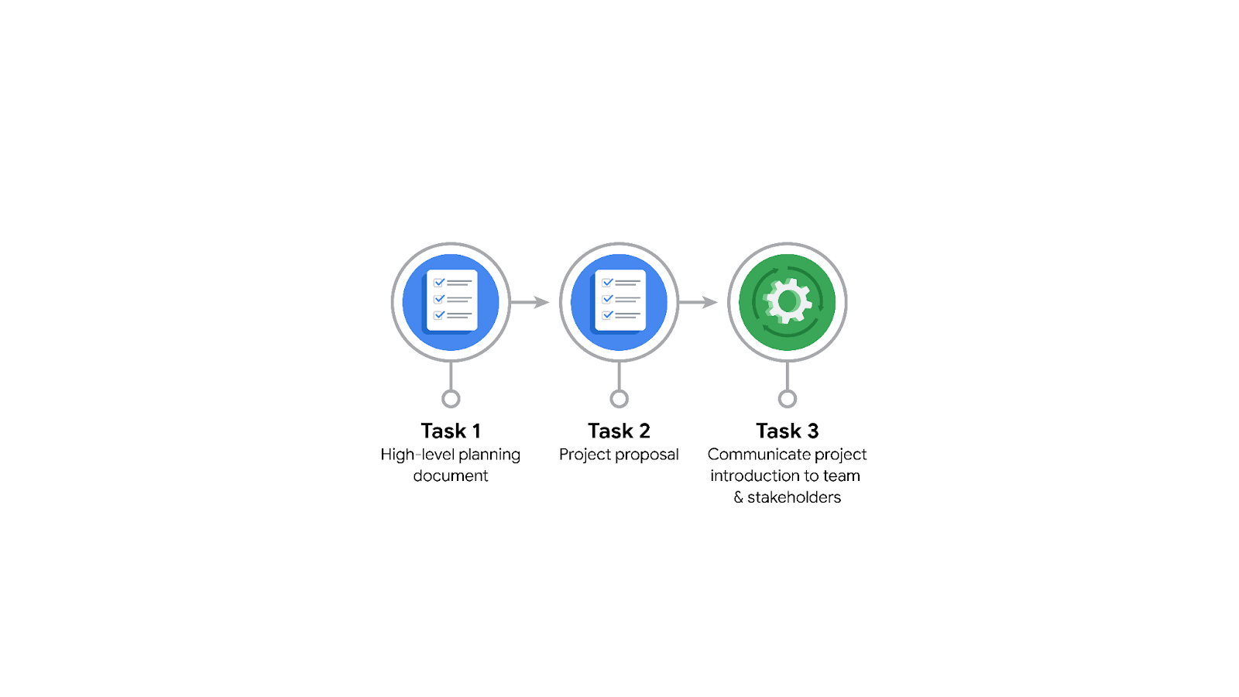

**Data Project Questions & Considerations**

**PACE: Plan Stage**

* Who is your audience for this project?

The audience will be the Waze data team and cross-functional team members

* What are you trying to solve or accomplish? And, what do you anticipate the impact of this work will be on the larger needs of the client?

The objective is to develop a machine learning model to predict user churn.

* What questions need to be asked or answered?

1. What is the condition of provided dataset?
2. What variables will be the most useful?
3. Are there any trends within the data that can provide insight?
4. What steps can I take to reduce the impact of bias?

* What resources are required to complete this project?

Project datasets, Python notebook, and inputs from stakeholders.

* What are the deliverables that will need to be created over the course of this project?

The deliverables include a dataset scrubbed for exploratory data analysis, visualizations, statistical models,

regression analysis/ machine learning model.

### **Project tasks**

Following are a group of tasks your company’s data team has determined need to be completed within this project. The data analysis manager has asked you to organize these tasks in preparation for the project proposal document.

1. **Evaluating the model:** Execute

Why did you select this stage for this task?

Once the model has been constructed, data is run through to assess whether it meets the expectations and goals of the projects.

1. **Conduct hypothesis testing:** Analyze **and** Construct

Why did you select these stages for this task?

During the analyzing stage, team determines that a statistical test will be used, which is followed by a construction phase in which the test is carried out.

1. **Begin exploring the data:** Analyze

Why did you select this stage for this task?

During the analysis phase, you get better understanding of the dataset and the information within it.

1. **Data exploration and cleaning:** Plan **and** Analyze

Why did you select these stages for this task?

Planning occurs when you decide on the necessary methods, followed by data cleaning process, which happens during the analysis stage.

1. **Establish structure for project workflow (PACE):** Plan

Why did you select this stage for this task?

In the planning stage, drafting an initial PACE document sets out the workflow and guides the best approach to the project.

1. **Communicate final insights with stakeholders:** Execute

Why did you select this stage for this task?

Communication is important at multiple stages of the project. The final insights are presented to stakeholders in the execution process of data project workflow.

1. **Compute descriptive statistics:** Analyze

Why did you select this stage for this task?

Investigating the statistics for the dataset happens during analysis.

1. **Visualization building:** Analyze **and** Construct

Why did you select these stages for this task?

Visualization starts with data assessment and is developed during the construction phase.

1. **Write a project proposal:** Plan

Why did you select this stage for this task?

A project proposal is the initial document that defines a project.

1. **Build a regression model:** Analyze **and** Construct

Why did you select this stage for this task?

In the analyzing stage, the model is closely examined to ensure it meets the requirements of the task. The regression model will be constructed during the construction phase.

1. **Compile summary information about the data:** Analyze

Why did you select this stage for this task?

Examining a dataset to gather information takes place during the analysis phase.

1. **Build machine learning model:** Construct

Why did you select this stage for this task?

**C**onstructing a data model would happen in the construct stage.